Using the Visual Builder for text edits

Step 1: Enable Visual Builder

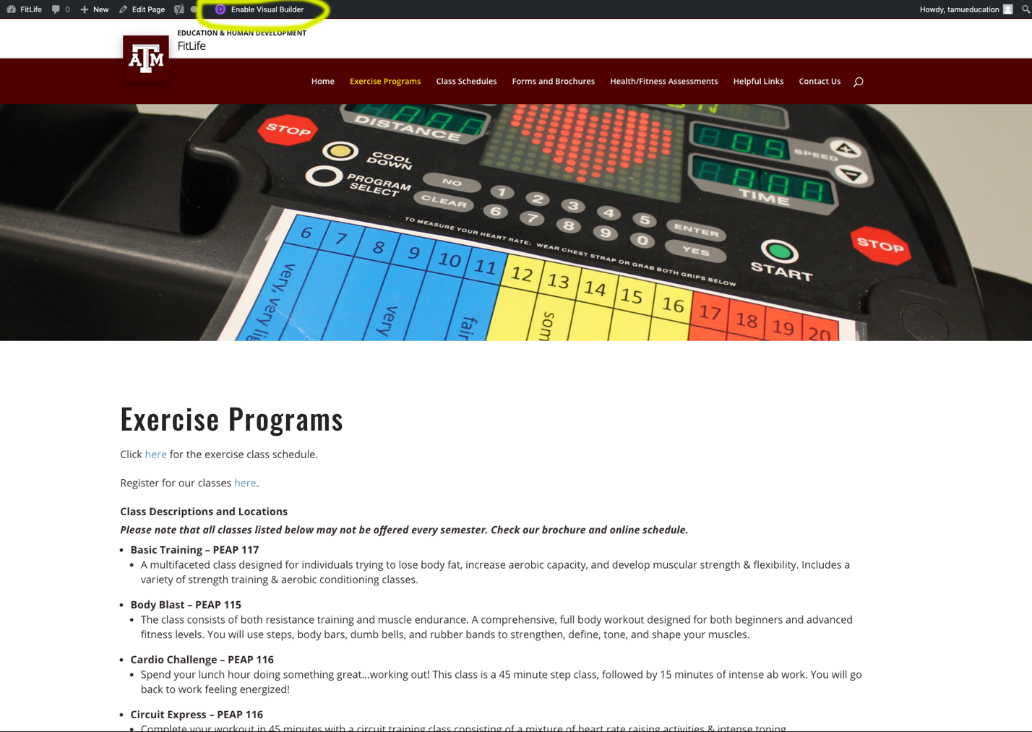

- When you are logged into WordPress and visit any of your website’s pages, a black bar will appear at the top.
- To enable the Visual Builder, click the link in that black bar – there is a purple icon next to it

Step 2: Select the content you want to edit

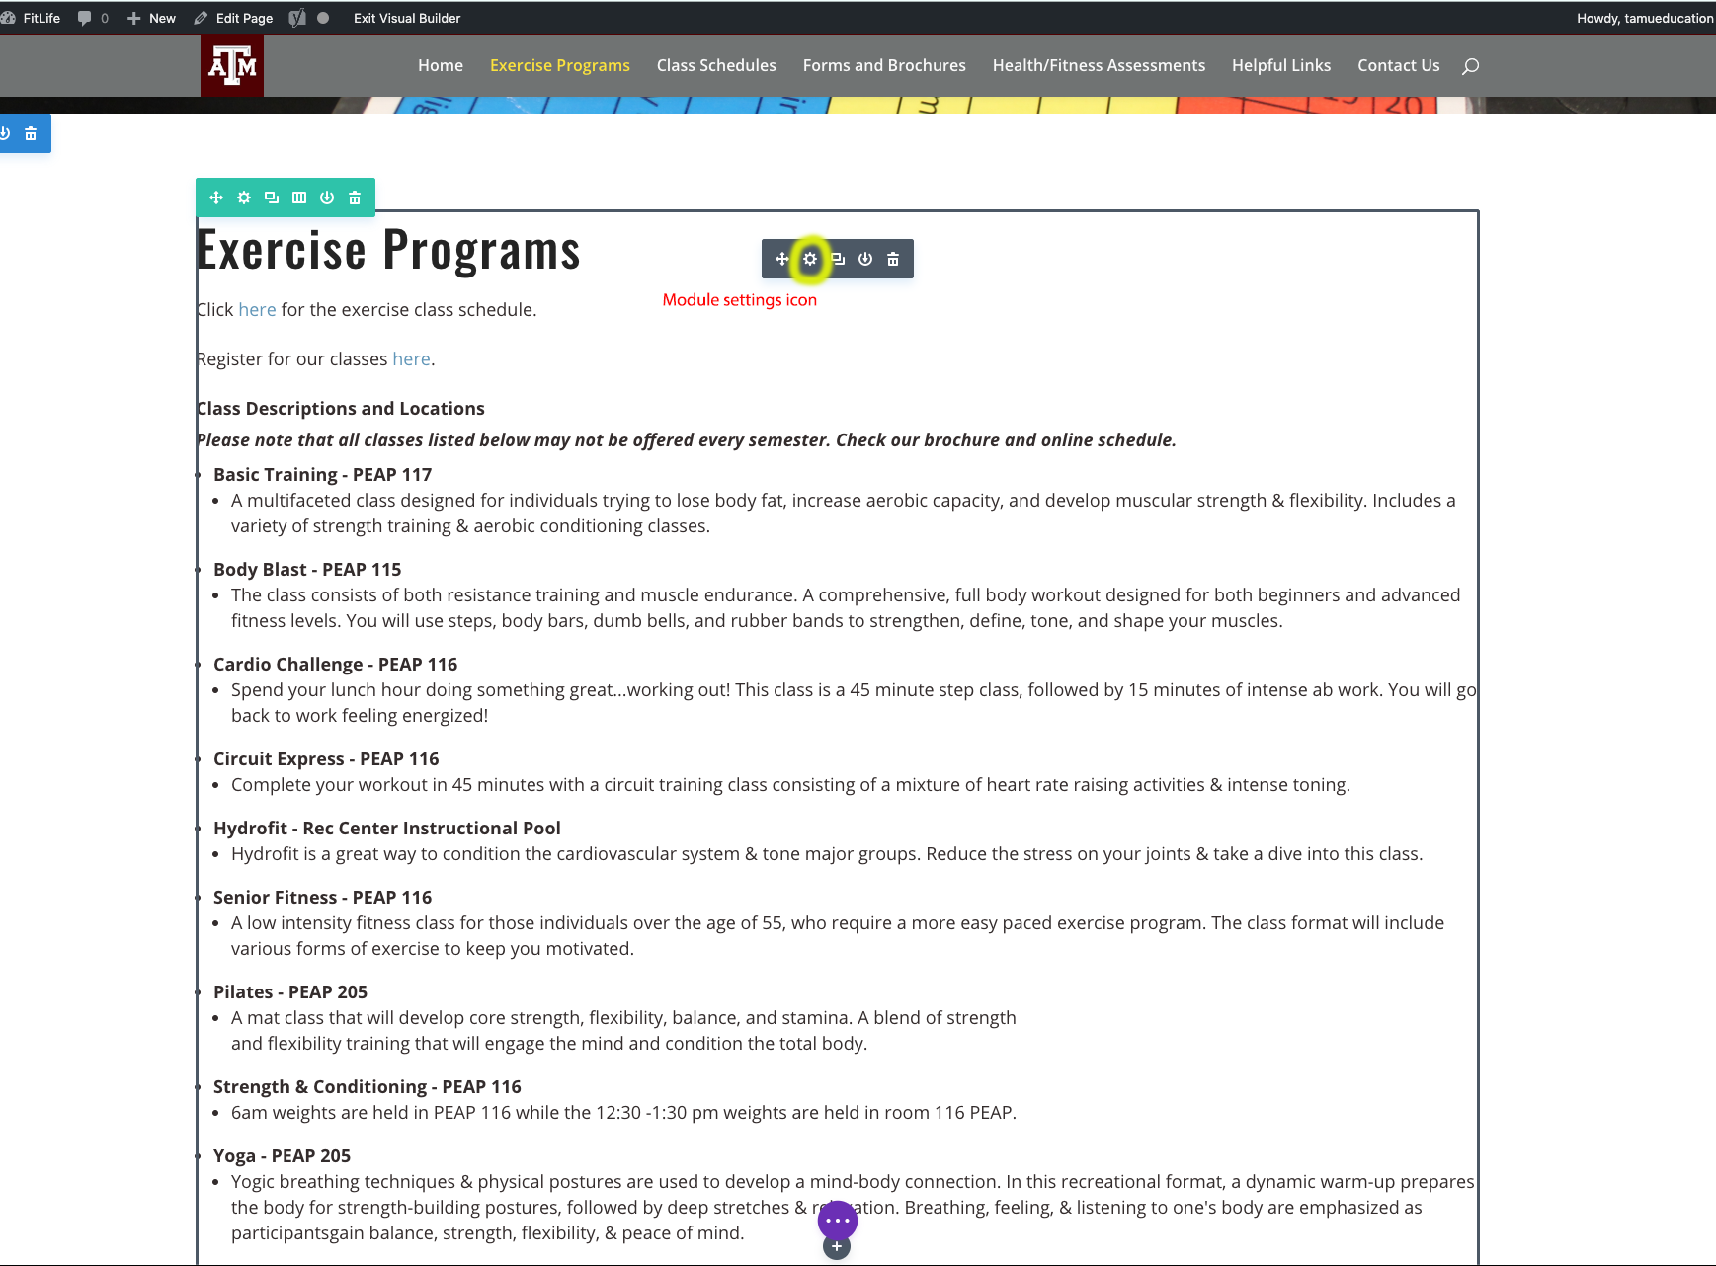

- Once the Visual Builder is enabled, hover over the content you want to edit.
- A grey box will appear around that content
- Click the module settings icon in in the smaller grey box

*Note that the other colored boxes that appear are for editing page background and other stylistic elements.

Step 3: Editing your content

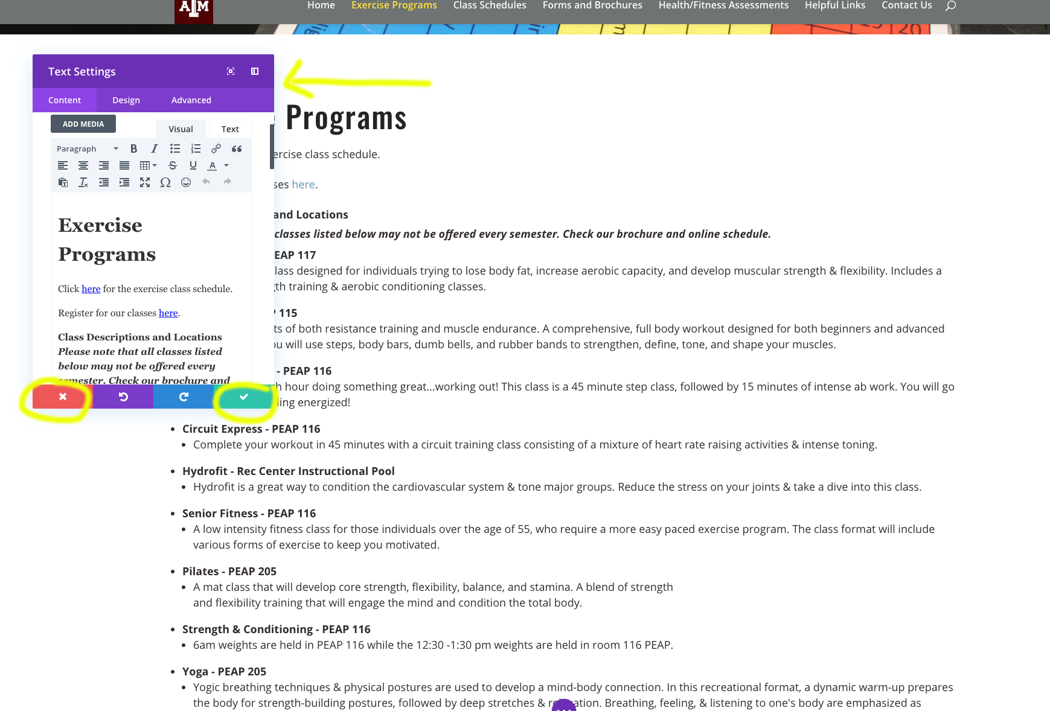

- After you click the module settings icon, a box will pop up that contains the content in that module.
- Editing works like it would in Microsoft Word – there are different paragraph settings, font settings, etc.
- Once you are finished editing your content, you can click the green check mark at the bottom right of the box.
- If you need to revert back to the original content or cancel what you have done, you can simply click the red x at the bottom left of the box.

*Note that the dark grey “ADD MEDIA” button that appears above the textual content can be used for uploading PDFs and linking to them.

Once you are finished editing your content, you can click “Exit Visual Builder” at the top of the page, and this will prompt you to save and exit. Your updated content will then appear on the live website.

